SPRINT DELIVERY – 4

Team ID | PNT2022TMID47004
Project Name | IoT Enabled Smart  Farming Application
Date | 18/11/2022

5.5 Receiving commands from IBM cloud using Python program
import time import sys import ibmiotf.application import ibmiotf.device import
random

#Provide your IBM Watson Device Credentials organization = "8jst89" deviceType = "abcd" deviceId = "14042" authMethod = "token" authToken =
"30042002"

# Initialize GPIO
def myCommandCallback(cmd): print("Command
received: %s" % cmd.data['command']) status=cmd.data['command'] if status=="motoron": print ("motor is on") elif status == "motoroff": print
("motor is off") else :
print ("please send proper command")

try:
deviceOptions = {"org": organization, "type": deviceType, "id": deviceId,
"auth-method": authMethod, "auth-token": authToken} deviceCli = ibmiotf.device.Client(deviceOptions)
#..............................................

except Exception as e: print("Caught exception connecting device: %s" %
str(e)) sys.exit()
# Connect and send a datapoint "hello" with value "world" into the cloud as an event of type "greeting" 10 times deviceCli.connect()

while True:
#Get Sensor Data from DHT11
temp=random.randint(90,110)
Humid=random.randint(60,100)
Mois=random. Randint(20,120)
data = { 'temp' : temp, 'Humid': Humid ,
‘Mois’: Mois}
#print data def myOnPublishCallback(
):
print ("Published Temperature = %s C" % temp, "Humidity = %s %%" % Humid, “Moisture =%s deg c” % Mois “to IBM Watson")
success = deviceCli.publishEvent("IoTSensor", "json", data,
qos=0, on_publish=myOnPublishCallback) if not success:
print("Not connected to IoTF")
time.sleep(10)
deviceCli.commandCallback = myCommandCallback # Disconnect the device and application from the cloud deviceCli.disconnect()
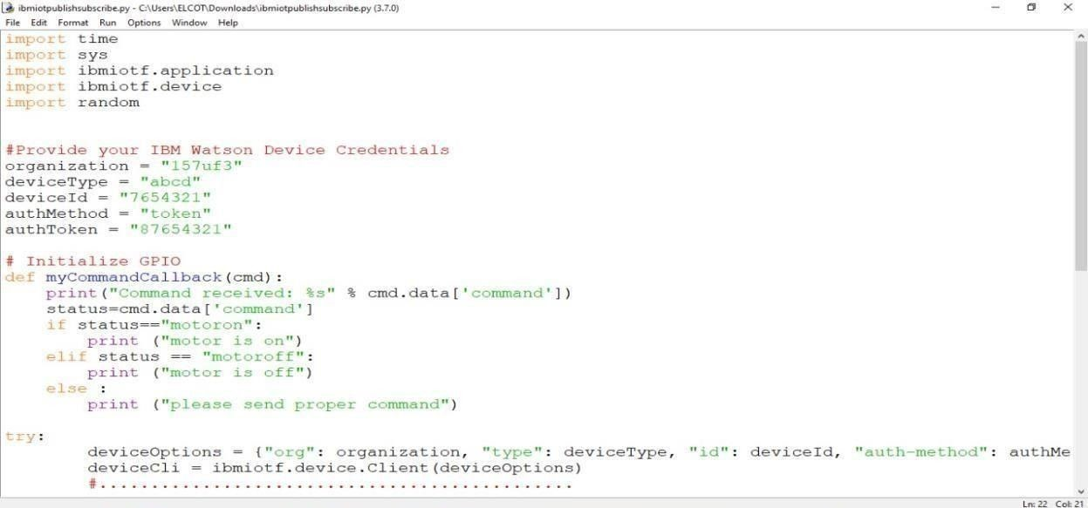

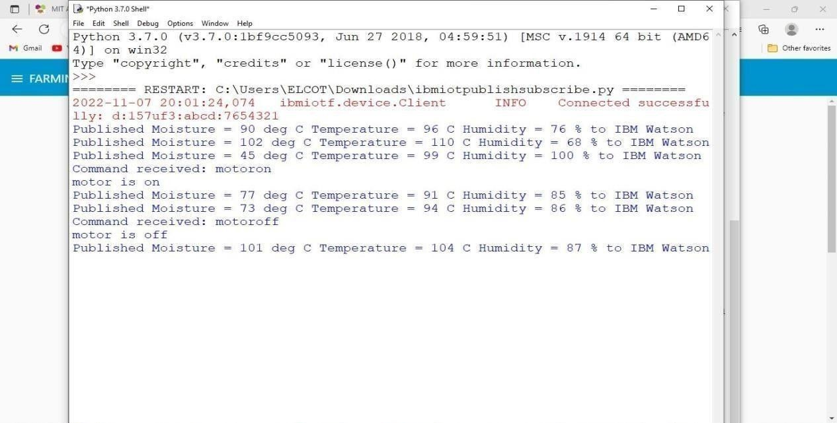
- Flow Chart
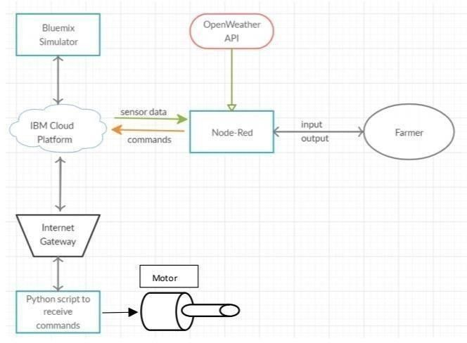

- Observations & Results

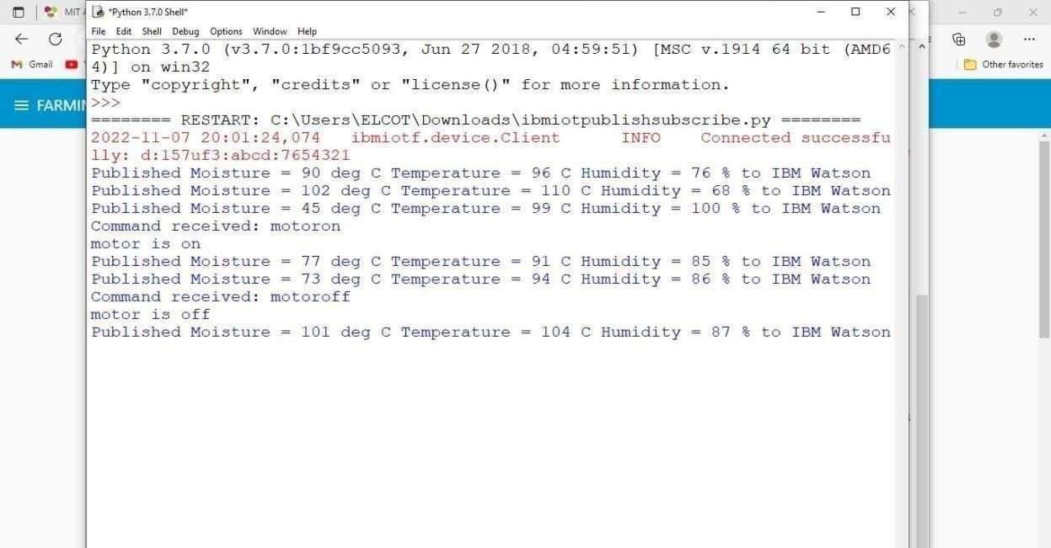
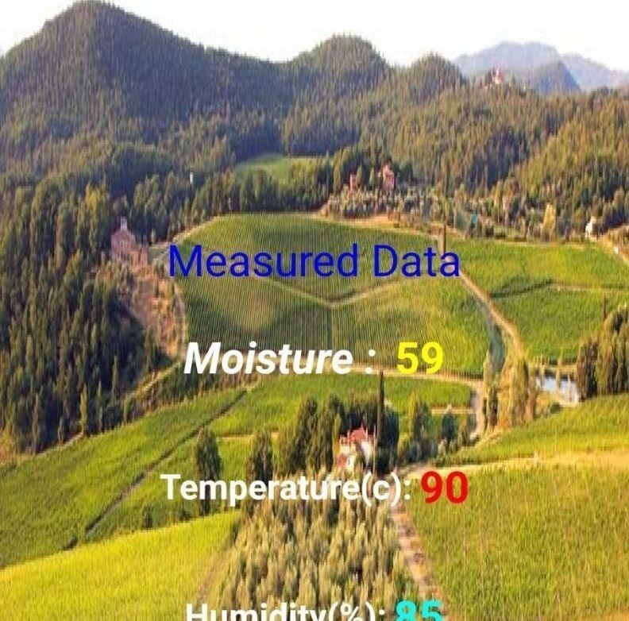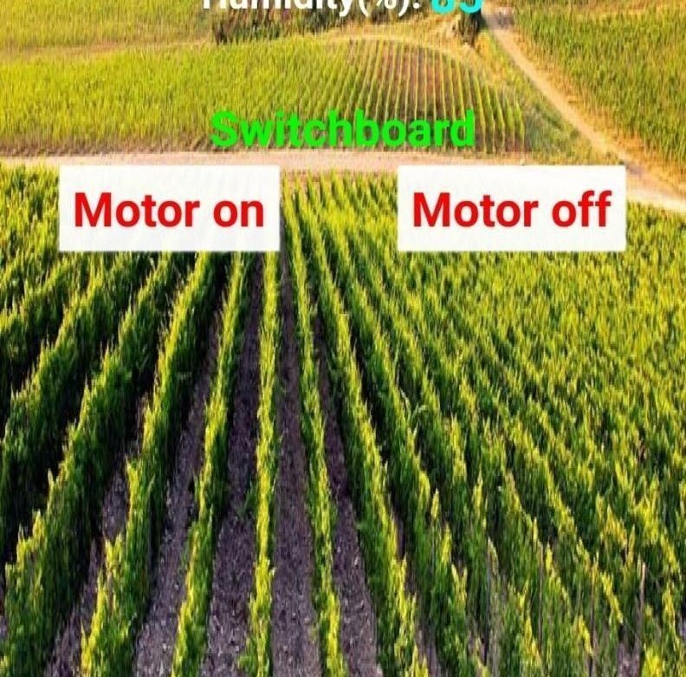
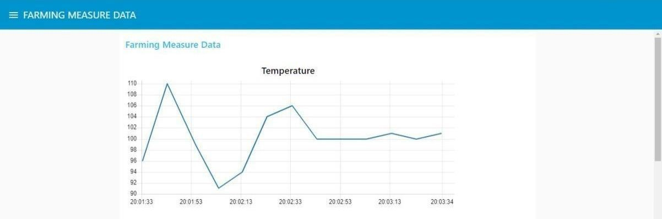



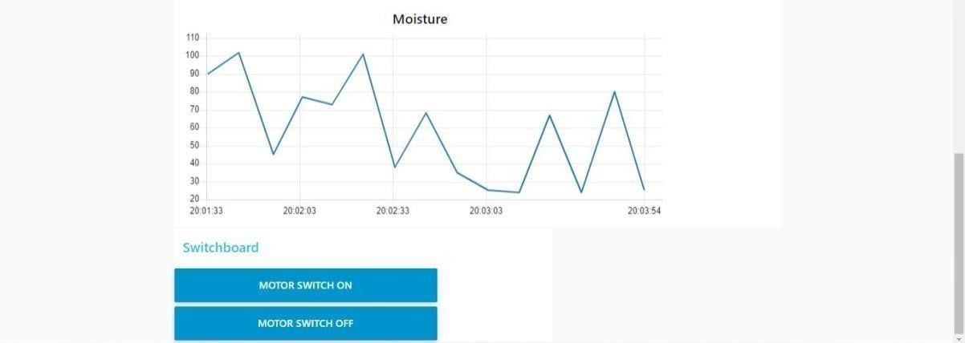
- Advantages & Disadvantages Advantages:
- Farms can be monitored and controlled remotely.
- Increase in convenience to farmers.
- Less labor cost.
- Better standards of living.
Disadvantages:
- Lack of internet/connectivity issues.
- Added cost of internet and internet gateway infrastructure.
- Farmers wanted to adapt the use of Mobile App.
9.Conclusion
Thus the objective of the project to implement an IOT system in order to help farmers to control and monitor their farms has been implemented successfully.

